ROTHWELL ARTS ELITE ACADEMY
Head Office
Springvale Studios
Watery Lane
Darwen
Lancashire
BB3 2ET
07852156651
www.rothwellarts.com

Elite Academy Brochure
Professional Training for The Arts
The Rothwell Arts Elite Training Programme Rothwell Arts has three Excellence Programmes which have been developed with the aim to nurture, support and train talented and promising individuals in all areas of the arts industry. The intake for the program is limited to ensure students are fully supported and receive individual attention. The professional tuition is provided in a supportive and encouraging environment offering positive reinforcement and promoting confidence in each student. Students are:
• Encouraged to work hard, set individual goals and maintain a high standard of dedication to dance.
• Mentored and guided to support their goals. Students are accepted and placed into the annual 35 week training programme based on competency and age.

Welcome
Welcome to Rothwell Arts Elite Academy Welcome to the Rothwell Arts Elite Academy. I am delighted to introduce you to our studio and our Academy’s Elite Training Programme. The RAEA training programs offer exciting and unique pathways for students to train in full-time dance whilst completing their primary, high school or college studies through supported education. Myself and my RAEA faculty would be absolutely delighted to be involved in the training of your child. RAEA academy’s faculty of dance and performing art teachers look forward to supporting and inspiring our students by creating a pathway for the advancement of their career goals in dance, the arts and this industry.
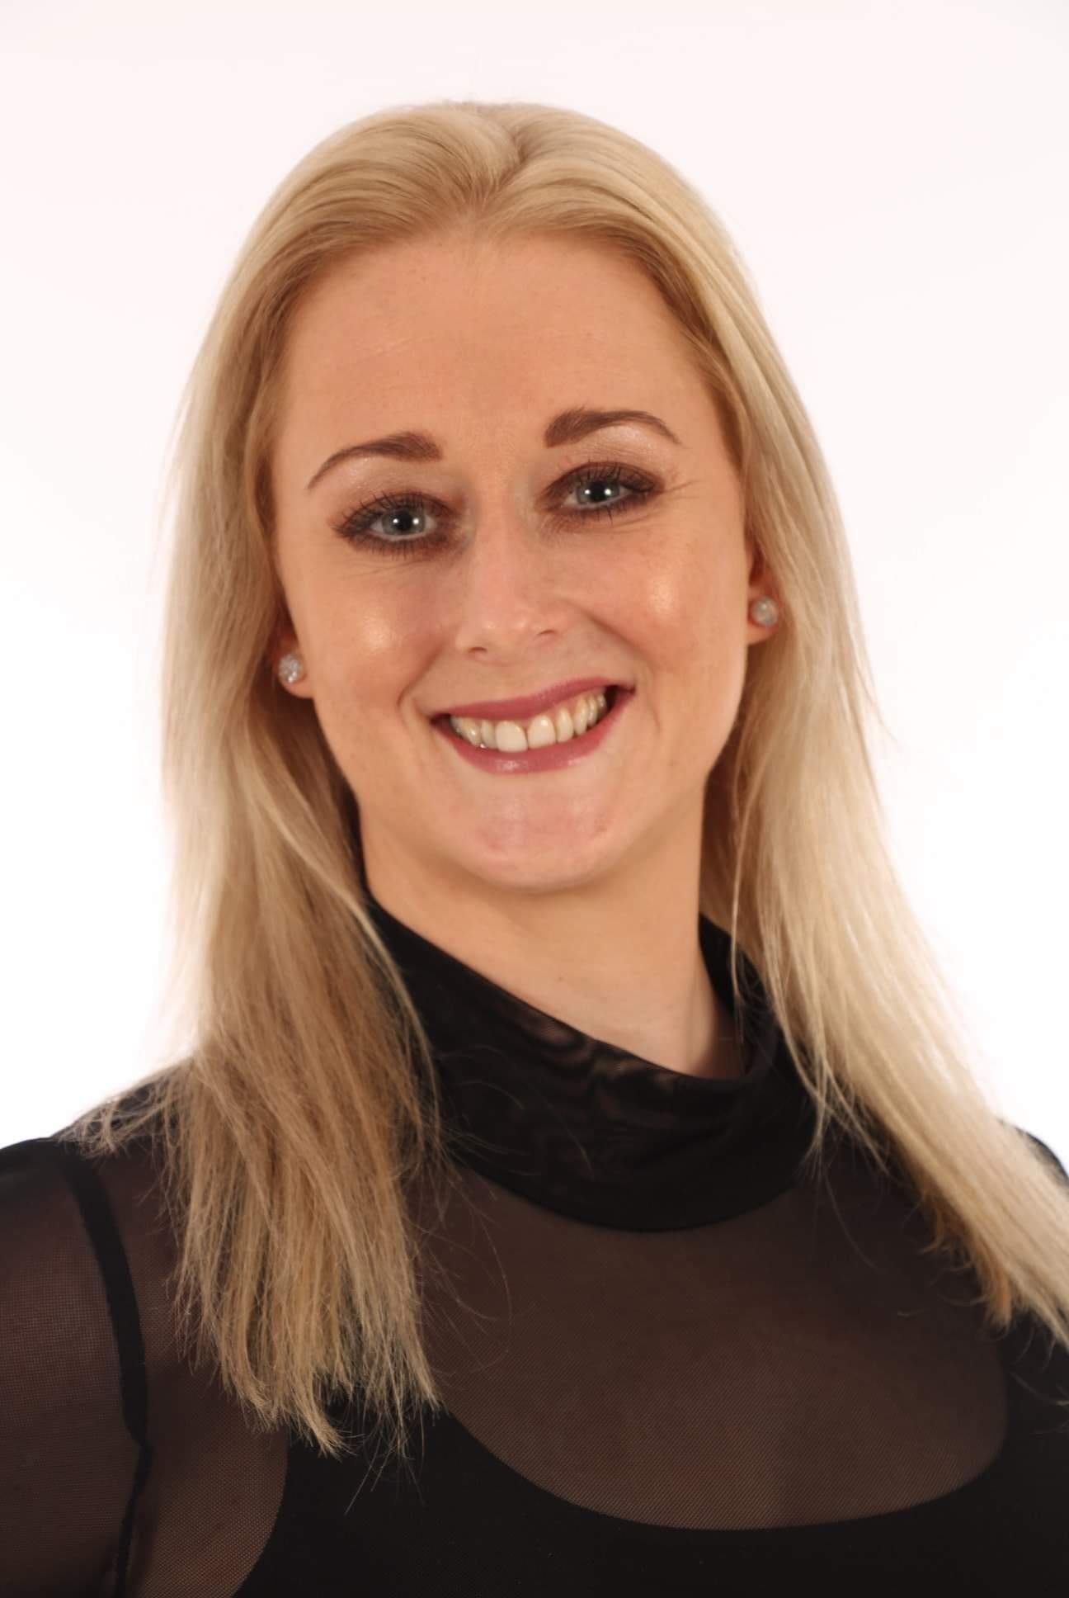

Warm regards

Vicky Rothwell - Director of Rothwell Arts Elite Training - Programme Specialist Coordinator Rothwell Arts School Principal
07852156651

Mission Statement
Mission Statement Our mission at the academy is to provide students from age 6 with more than just dance or performing arts classes, but a unique experience in which the student can grow both mentally and physically as a performer in whatever direction an individual wishes to take. Our highly trained and certified instructors have a wealth of experience spanning over 25 years. We know that the arts can make a huge impact on someone’s life and that starts with the correct training in technique, confidence, self-belief, teamwork, friendship and above all else the skills to move from our training programme to the next stage of a student’s career. Our teaching faculty simply want you to be the best you can be.

Training Programmes
Training Level 1
The training for this level focuses on establishing the foundation of all round technique, musicality and expression. In addition, body conditioning and strengthening coupled with technique development are fundamental to the programme. Students may begin the programme from the age of 6 years of age. Dedicated tutors are provided to assist and supervise weekly study sessions and guide the students through their academic curriculum.
Level 1 Programme Overview
Dance and Performing Arts Classes in all genres, Classical Ballet Group and Solo Repertoire Solo Performance Coaching, Pilates, Character Dance Contemporary Dance, Commercial, Street Dance , Jazz, Body Conditioning, Flex and Stretch, Progressing Ballet Technique, Musical Theatre, Drama, Acting Competition choreography, Nutrition, festival solos.
Please see the timetable for all 35 week classes.
The training for this level focuses on establishing a strong foundation of all round technique, musicality and expression. In addition, body conditioning and strengthening coupled with technique development are fundamental to the programme. Students may begin the programme from the age of 6 years of age dedicated tutors are provided to assist and supervise weekly study sessions and guide the students through their academic curriculum.
Training Level 2
The training for this level focuses on establishing a strong foundation of all round technique, musicality and expression. In addition, body conditioning and strengthening coupled with technique development are fundamental to the programme. Our programme of study sessions provide the students through their academic curriculum working at all times to create a sense of performance in all areas.
Level 2 Programme Overview
Dance and Performing Arts Classes in all genres, Classical Ballet Group and Solo Repertoire Solo Performance Coaching, Pilates, Character Dance, Contemporary Dance, Commercial, Street Dance ,Jazz, Body Conditioning, Flex and Stretch, Progressing Ballet Technique, Musical Theatre, Drama, Acting, Competition work, choreography, Nutrition, festival and competitive work.
Please see the timetable for all 35 week classes ( separate document )
Training Level 3
Level 3 is ready for the already established dancer and performer in all areas.The vocational standard of training for these age and ability students focuses on enhancing the already set foundations of all techniques. Students must have an understanding of musicality, performance and artistic expression internally and externally. There is also a strong focus on body conditioning and strengthening which is crucial to all areas of the arts. This Level is decided on an individual basis by the course director during an interview stage of acceptance into the study course. Students in this group work at a fast pace and it is expected that the level of current training is overall of an excellent standard. This level is not determined by age but by ability.
Level 3 Programme Overview
Dance and Performing Arts studies in all genres, Classical Ballet & Pointe Coaching, Group and Solo Repertoire, Pas De Deux, Solo Performance Coaching, Pilates & Body Conditioning, Contemporary & Lyrical Dance, Commercial, Street Dance, Jazz, Musical Theatre, Drama, Acting, Acrobatics, Competition work, choreography, Individual Career Planning, Professional Development, Human Anatomy, Music Appreciation, Nutrition and Dance History.
Please see the timetable for all 35 week classes ( separate document )
Prerequisites
The Elite Academy is not for total beginners; the academy has been designed to enhance all skills at a quicker pace for those who have prior experience, those wishing to technically enhance their skills at a faster pace or for established individuals. Students do not have to currently study everything on offer in the levels in weekly classes but must study something so there is an understanding or what is going to be required of them throughout this programme of study.This also helps the programme director to determine the education levels for each person position within this training programme.
Expectations
Students will be expected to always work to the highest level of ability in class and anytime representing the academy. You will be expected to perform when asked in recitals, shows, competitions, festivals and bursary seminars throughout the year in various places throughout the UK. This is to enhance the performance level and put into practice the training they are being given, this will allow regular feedback for themselves and our teaching faculty.
Assessment Procedure
To ensure students are progressing satisfactorily, they will be assessed regularly throughout the 35 weeks by performance level in and out of class along with formal examinations and homework studies ( where appropriate ) in all areas of study. Feedback on their progress will be given regularly either by in studio meetings or through our online portals. Reports are issued annually.
Teaching Faculty
The dedicated faculty of experienced and handpicked teachers for this programme are industry professionals, covering all aspects of industry life. They are committed to nurturing and guiding each student in their relevant field of knowledge. Guest Teachers - These are continually implemented throughout the 35 week programme
Vicky Rothwell –School Principal, Director, Course specialist, Vocational Training, Examinations
Jessica Porter – Drama, Acting, Musical Theatre
Vicki Galvin – Dance Studies, Acrobatics, Choreographer
Wendy Scott-Kay – Classical Ballet, Pas De Deux, Character Dance, National Dance, Music Appreciation
Emily Cross- Jazz, Cabaret, Musical Theatre, Body Conditioning
Darci Hunt- Commercial, Street, Hip Hop, Locking, popping
Terms & Conditions
Elite classes run 35 weeks of the year term time only 1-4.30pm unless otherwise stated and agreed. You will be required to be at the studio 15 minutes before your start time to efficiently warm up and make sure you are ready with all items you require in the studio. Please bring all shoes and equipment to each Elite Training Session. Uniform is essential along with school etiquette with hair up and smartly groomed at all times. All Elite Academy students require a Rothwell Arts tracksuit. We are also aware that from time to time you may not be able to attend due to commitments / holidays and such like.
Annual Training
This programme is available every academic year. Your child will naturally stay with the programme and move around the programme levels when ready.
School App
The Academy has a well established app and you and your child ( child age dependant ) will be added to our Elite Team group. This acts as a noticeboard and you will be required to check this often should the notification not arrive to you when added. Technology on occasions has a mind of its own so we would ask you to be thoughtful and check regularly what's on your specific page. Although we have a school app the course director will email you with specific requirements for items, dates or anything of importance that you need to know when required. Our aim and objective is that all parties know exactly what they are doing at all times.
Departure
If you decide the training programme is not for you a 2-month leaving notification is required by email. Whether you choose to send your child to these is your choice, but it must still be paid for and can not be used in conjunction with any other offer or promotion with the school in any way. The two month period allows time to advertise the place which you hold out to another participant. It also allows the academy faculty to teach in an effective manner any competitive work before you leave. Should you and the school have already committed to an event in payment and organisation, and if there is not enough time for the change over of students to fit in competitive work then you will be expected to fulfil your commitment to the remaining students in those numbers without prejudice and to the best of your ability.
If you are asked to leave the programme with immediate effect the course director will liaise with you on any financial commitments to the programme.
If we close the academy programme you will be issued with a two month notification period. All areas of work will be carried out in this time without prejudice and to the best of our ability.
Payments
Elite payments are made on the 5th of each month. The cost is £59.95 per calendar month.
Rothwell Arts Business Account: Sort Code XXXXXX Account Number XXXXXXXX
Payment reference is your child’s name. If a child’s name is too long for the reference box then the last name of the family is required. Your payment acts as your receipt as you can track your transaction via your bank. If you would like a paper receipt please do this by asking the school principal each month in writing by email to vicky@rothwellarts.com and this will be done electronically. No cash payments are accepted under any circumstances. All payments must be done via direct debit or standing orders set up by yourself. A £30 non-refundable deposit is required to secure the place at the time of acceptance onto the programme and also includes your child academy tee shirt. Private Lessons for solos will also be at a reduced rate for Elite students, along with priority booking for all private classes.
How to apply
Please contact the course administrator and School Principal Vicky Rothwell through the office email: vicky@rothwellarts.com
Book your child onto now this programme of study today
Find us on our social media platforms
Facebook - Rothwell Arts
Tik Tok - Rothwell Arts Dance Academy
Instagram - rothwell_arts
Twitter - @rothwellarts

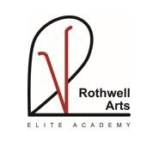
Thank you for choosing Rothwell Arts Elite Academy for your child
Warm Wishes
Vicky Rothwell

